**Configure an AWS IoT Button**

The easiest way to configure your AWS IoT button is by using the AWS IoT button smart phone app. You can download it from the [Apple App Store](https://itunes.apple.com/us/app/aws-iot-button/id1178216626) or the [Google Play Store](https://play.google.com/store/apps/details?id=com.amazonaws.iotbutton). If you are unable to use the smart phone app, follow these directions to configure your button:

**To configure your AWS IoT button:**

**Turn on your device**

1. Remove the AWS IoT button from its packaging, and then press and hold the button until a blue blinking light appears. (This should take no longer than 15 seconds.)
2. The button acts as a Wi-Fi access point, so when your computer searches for Wi-Fi networks, it will find one called **Button ConfigureMe - XXX** where *XXX* is a three-character string generated by the button. Use your computer to connect to the button's Wi-Fi access point.
3. The first time you connect to the button's Wi-Fi access point, you will be prompted for the WPA2-PSK password. Type the last 8 characters of the device serial number (DSN). You'll find the DSN on the back of the device, as shown here:

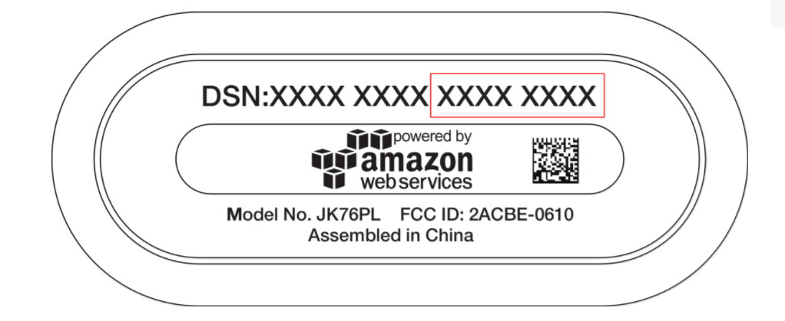

**Copy your device certificate and private key onto your AWS IoT button**

To connect to AWS IoT, you must copy your device certificate onto the AWS IoT button.

1. In a browser, navigate to <http://192.168.0.1/index.html>.
2. Complete the configuration form.
   * Type your Wi-Fi SSID and password.
   * Browse to and select your certificate and private key.
   * Find your custom endpoint in the [AWS IoT console](https://console.aws.amazon.com/iot/home?region=us-east-1#/dashboard/help). (From the dashboard, in the left navigation pane, choose**Registry** to expand the selection, and then choose **Things**. Select the box representing your button to show its details page. On the details page, in the left navigation pane, choose **Interact** and look for the **HTTPS** section.) Your endpoint will look something like the following:

**Copy**

ABCDEFG1234567.iot.us-east-2.amazonaws.com

where ABCDEFG1234567 is the subdomain and us-east-2 is the region.

* + On the **Button ConfigureMe** page, type the subdomain, and then choose the region that matches the region in your AWS IoT endpoint.
  + Select the **Terms and Conditions** check box. Your settings should now look like the following:

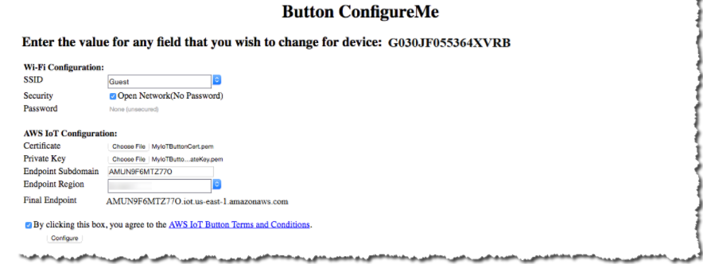

* + Choose **Configure**. Your button should now connect to your Wi-Fi network.

**Configure a Different Device**

Consult your device's documentation to connect to it and copy your device certificate, private key and root CA certificate onto your device.

**How to obtain your certificate and private key**

1. Select from Services 🡪 AWS IoT

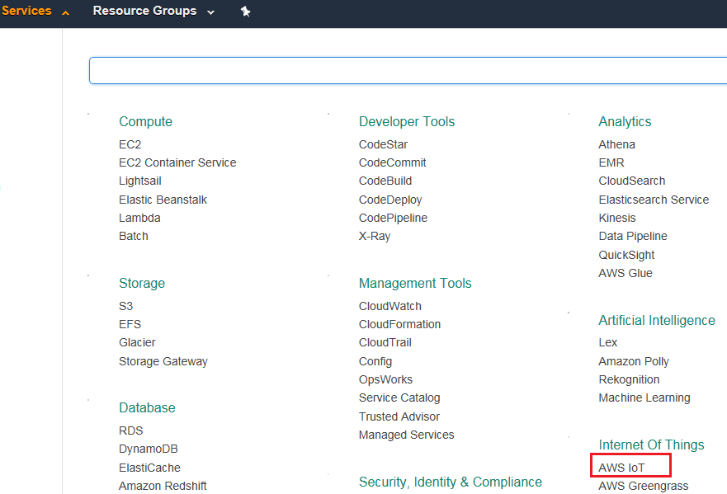

1. Click on Get started

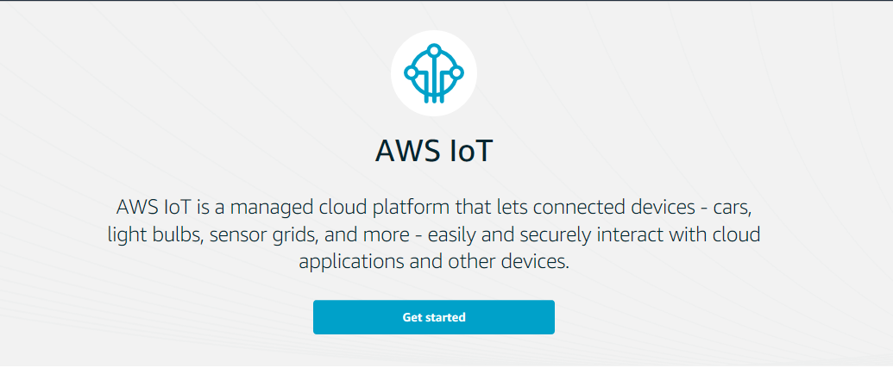

1. In the left you have the menu, click on Security 🡪 Certificates 🡪 Create Certificate

